

Branching

[1]



It doesn't return a value

[1]



Black box testing is done by non-specialists that don’t understand the inner workings of the program

[3]



|  |  |  |
| --- | --- | --- |
| **Test Type** | **Test Data 1** | **Test Data 2** |
| Normal | 50 | 51 |
| Extreme | 100 | 0 |
| Invalid | 101 | -1 |

[3]

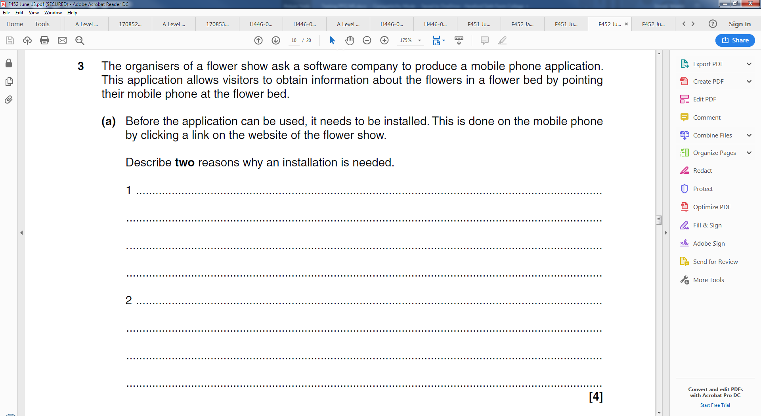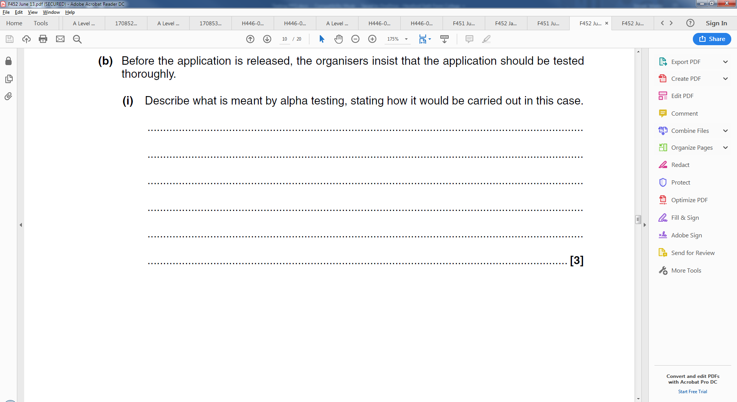

[3]

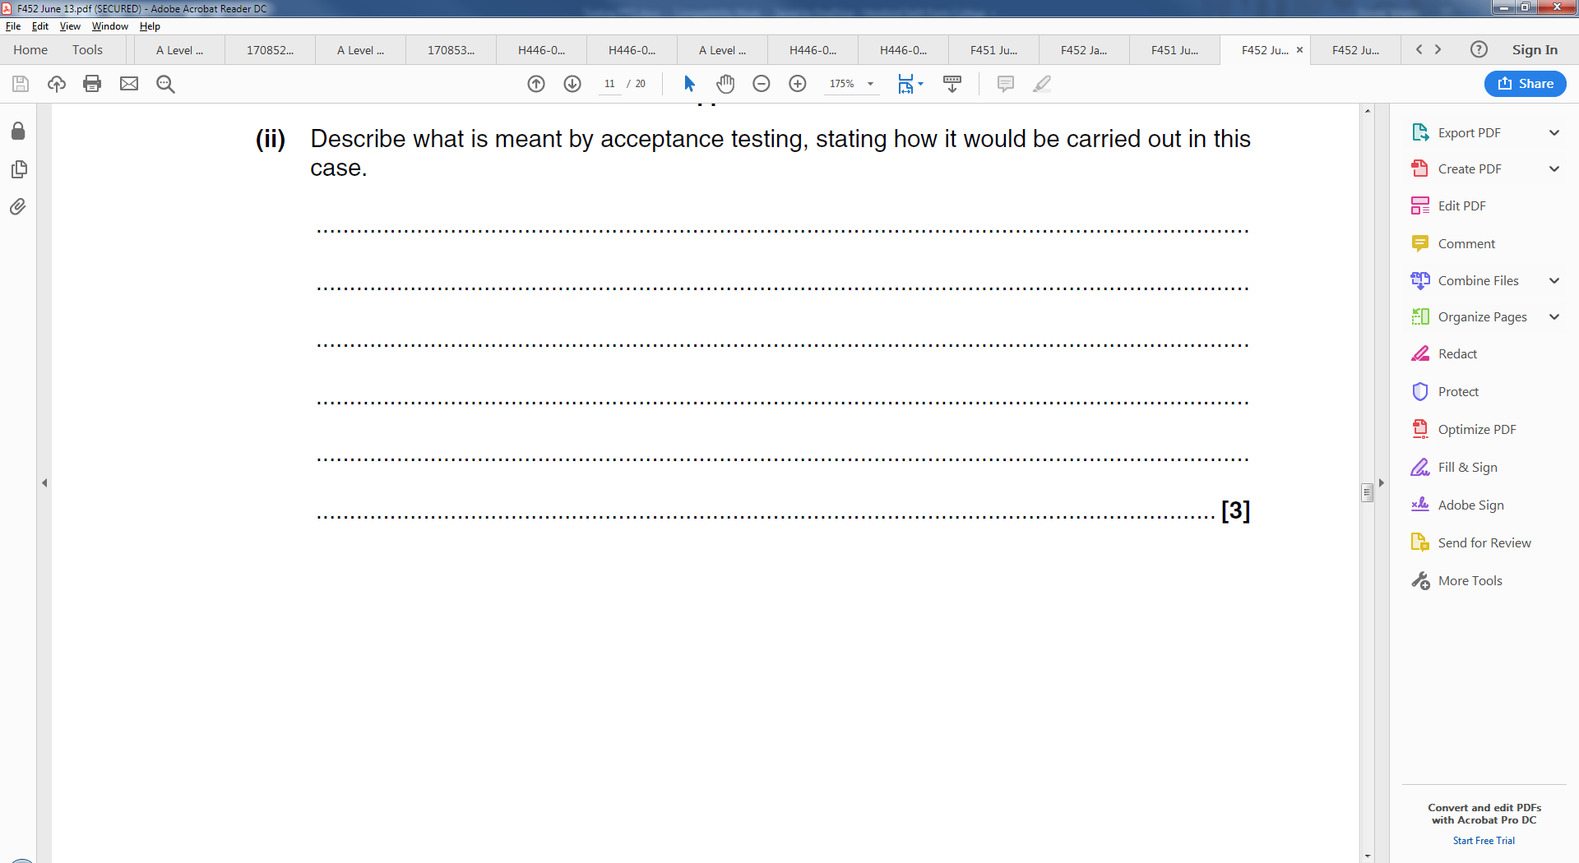

[3]